**Air Cargo Analysis - Screenshots**

**Task 1: ER Diagram**

**  
  
Task 2: Create Route Details Table with Constraints**  
  
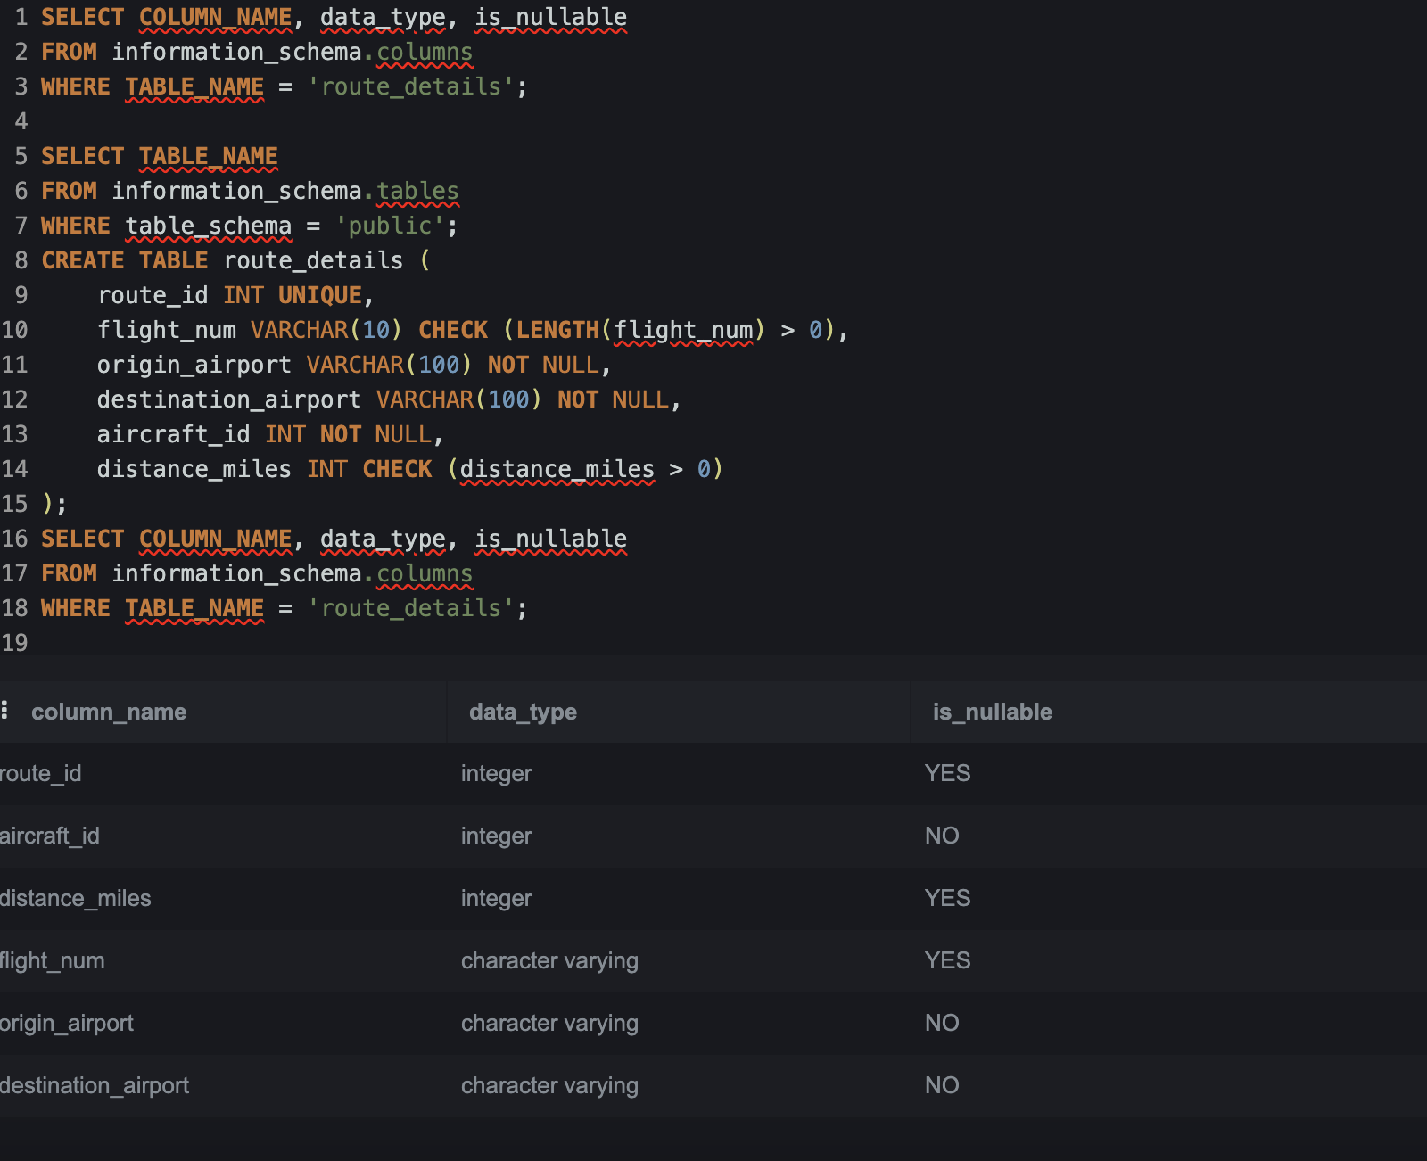

**Task 3: Display All Passengers Who Travelled in Routes 01–25**

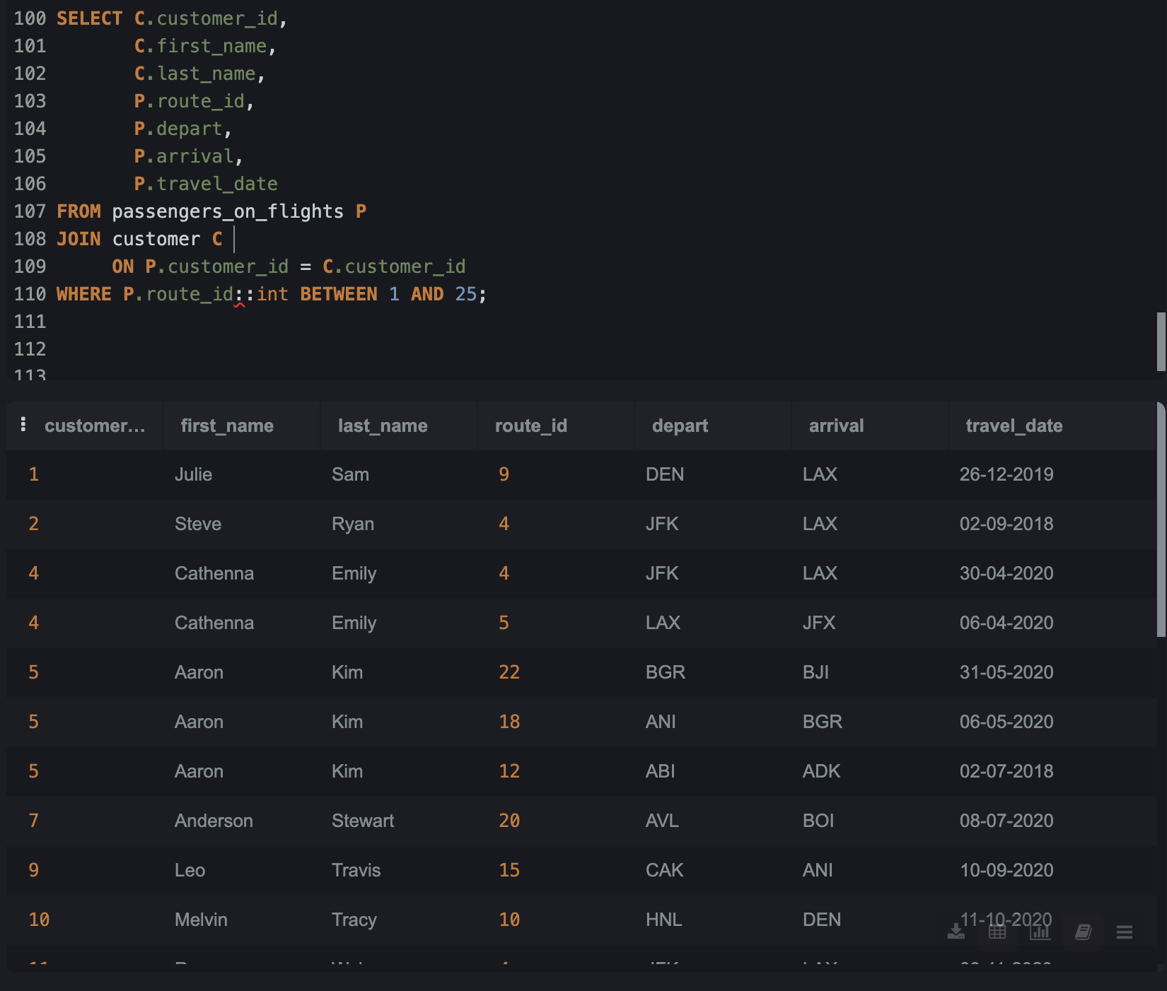

**Task 4: Identify the Number of Passengers and Total Revenue in Business Class**

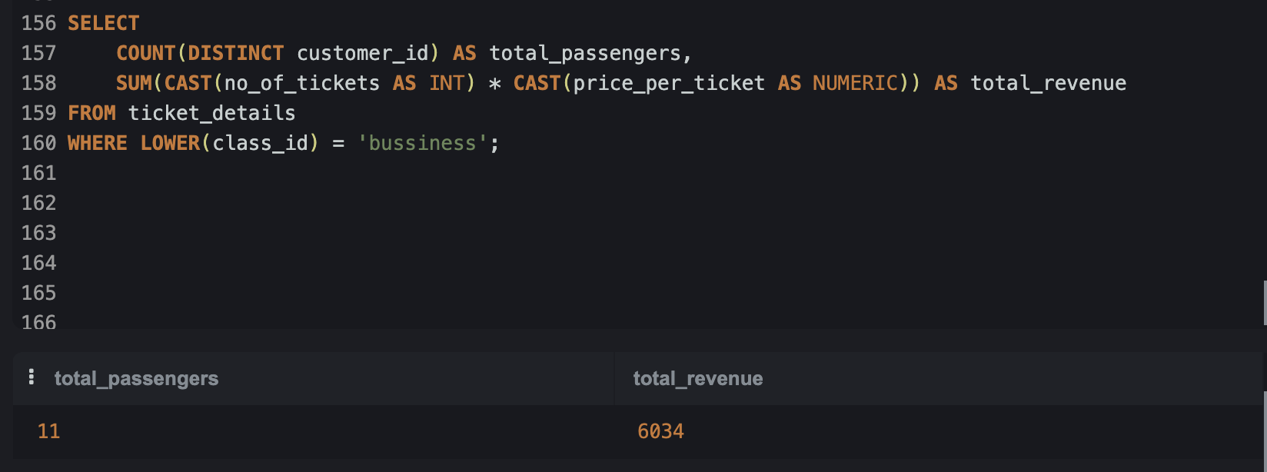

**Task 5: query to display the full name of the customer by extracting the**

**first name and last name from the customer table**  
  
**Task 6: Extract Customers Who Have Registered and Booked a Ticket**

**Task 7: Identify Customers Who Have Booked Tickets with Brand ‘Emirates’**

**Task 8: Identify Customers Who Travelled by Economy Plus Class**

**Task 9: Identify Whether the Total Revenue Has Crossed 10,000 Using IF**

**Task 10: Create and Grant Access to a New User**

Execution failed on SQL Online AiDE due to restricted permissions, but this query is correct for a local PostgreSQL environment.

**Task 11: Find the Maximum Ticket Price for Each Class Using Window Functions**

**Task 12: Extract Passengers Whose Route ID is 4 (with Performance Optimization)**

**Task 13: View the Execution Plan for Route ID = 4 Query**

**Task 14: Calculate the Total Ticket Price of All Tickets Booked by Each Customer Across Different Aircraft IDs (Using ROLLUP)**

**Task 15: Create a View with Only Business Class Customers Along with the Brand of Airlines**

**Task 16: Create a Stored Procedure to Get Passenger Details Between a Range of Routes**

**Task 17 – Stored Procedure for Routes Where Distance > 2000 Miles.**

**Task 18: Create a Stored Procedure to Group Flights by Distance Category (SDT, IDT, LDT)**

**Task 19: Stored Function to Specify Complimentary Services Based on Class**

**Task 20: Stored Procedure Using Cursor to Fetch the First Record of a Customer Whose Last Name Ends with ‘Scott’**

